Types of Data

[John S Butler (TU Dublin)](https://johnsbutler.netlify.com)

# Types of Data

1. Categorical
2. Ordinal
3. Interval
4. Ratio

## Categorical Data

### Definition:

Categorical data is the statistical data type consisting of categorical variables or of data that has been converted into that form, for example as grouped data.

### Example of Categorical Data

If you ask a number of people their age, you can categorise them into age groups. Each person can only be assigned to one age group. This kind of data can be illustrated as a pie chart or a bar chart.

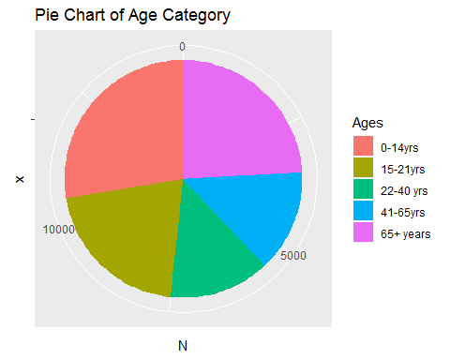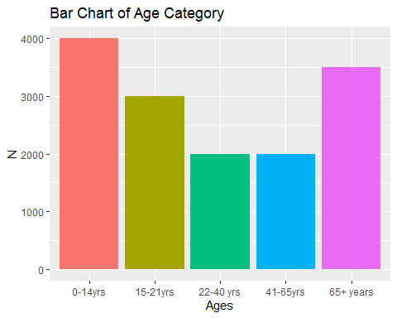

## Ordinal Data

### Definition:

Ordinal data is a categorical, statistical data type where the variables have natural, ordered categories and the distances between the categories is not known.

## Example:

A survey asked, “Do you like Marmite?” and gave 5 possible response:

1. Strongly Disagree
2. Disagree
3. Neutral
4. Agree
5. Strongly Agree

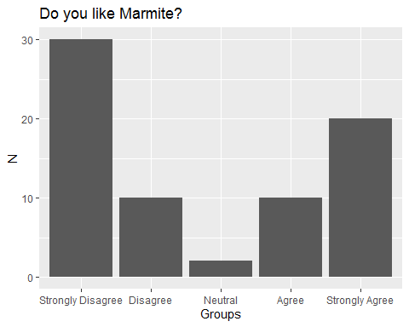

## Interval Data

### Definition:

Interval data is defined as a data type which is measured along a scale, each step in the scale has the same meaning.

## Example:

Height is a lovely example of interval data a centimeter is always a centimeter.

## `stat_bin()` using `bins = 30`. Pick better value with `binwidth`.

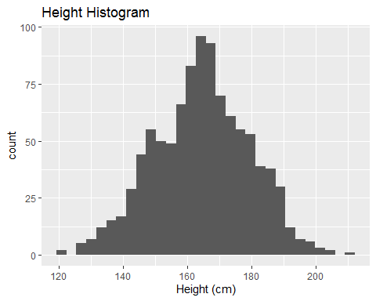

## Interval Data

### Definition:

Interval data is defined as a data type which is measured along a scale, each step in the scale has the same meaning.

## Example:

People Height Distribution

## `stat_bin()` using `bins = 30`. Pick better value with `binwidth`.

